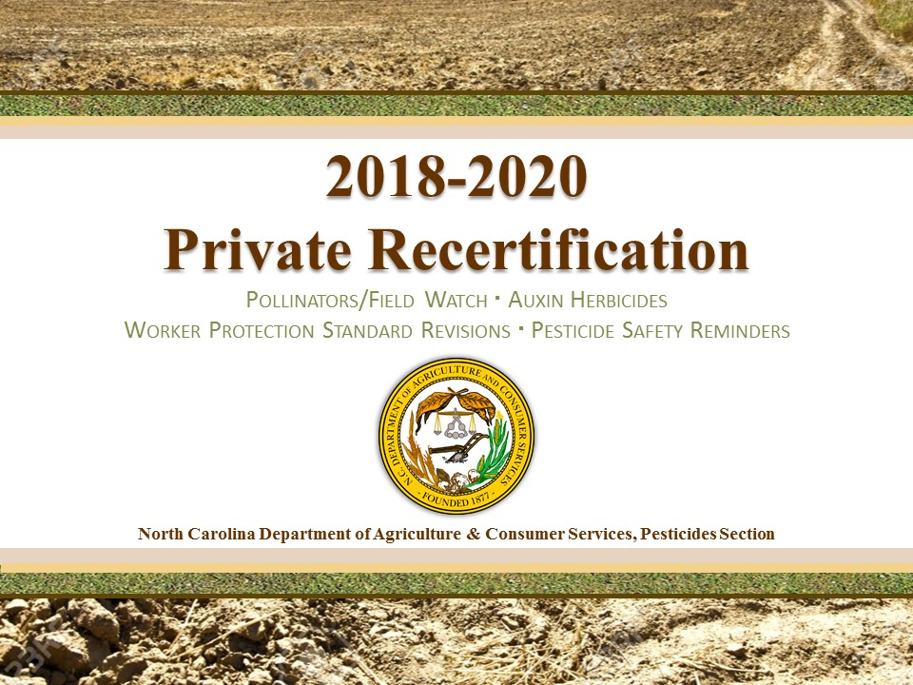

Topics for the 2018-2020 Private Recertification period include: A continuing effort to protect pollinators and increase awareness of the Field Watch tool. Auxin herbicides labeling and precautions that need to be taken when using these products. An update on the Worker Protection Standard including current and revised regulations. Pesticide safety reminders on chemical storage with a focus on chemical poisoning.

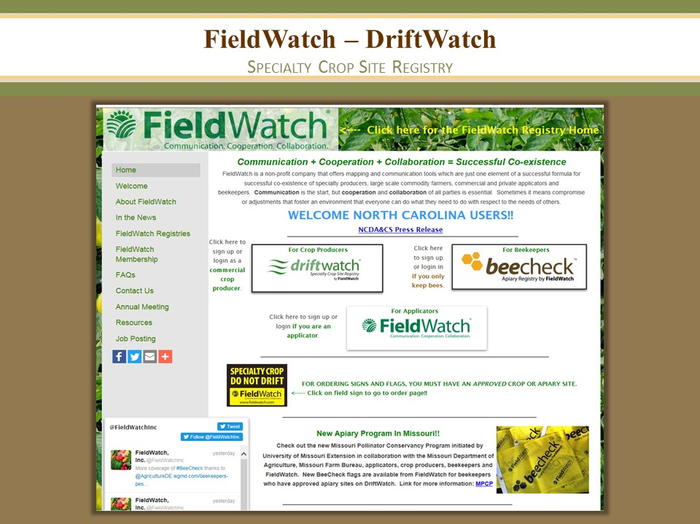

The N.C. Department of Agriculture and Consumer Services' Pesticide Section, with funding from the Pesticide Environmental Trust Fund, has purchased DriftWatch software, a voluntary communication tool that enables crop producers, beekeepers, and pesticide applicators to work together to protect specialty crops and apiaries through use of the DriftWatch registry mapping program.

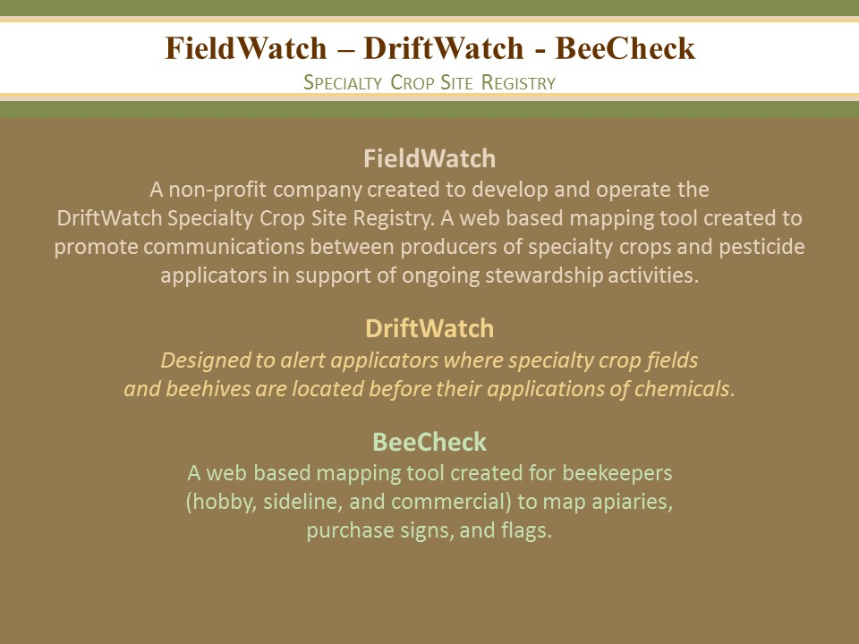

FieldWatch, Inc. is a non-profit company created to develop and expand the operation of the DriftWatch Specialty Crop Site Registry. To support the rapid growth of DriftWatch outside of Indiana, Purdue University collaborated with other agricultural stakeholder groups in the creation of a non-profit corporation called FieldWatch in December 2013. The new company, which is located off-campus at the Purdue Research Park in West Lafayette, IN, has fully assumed the operational responsibilities of DriftWatch and developed a national platform for the website. DriftWatch is a voluntary online specialty crop site registry and mapping program created by Purdue's Agriculture Department. The University's successful web based program, launched in Indiana in 2008, has been effective in allowing both farmers and applicators to identify, map and communicate where high-value pesticide-sensitive crops are being grown as part of ongoing stewardship activities. DriftWatch has quickly caught the attention of other states and provinces in Canada. As a primary stakeholder, the respective state departments of agriculture provide a key leadership role in implementing, administering and financially supporting this effective stewardship communication tool.
DriftWatch is a voluntary online specialty crop site registry and mapping program created by Purdue's Agriculture Department. The University's successful web based program, launched in Indiana in 2008, has been effective in allowing both farmers and applicators to identify, map and communicate where high-value pesticide-sensitive crops are being grown as part of ongoing stewardship activities. DriftWatch has quickly caught the attention of other states and provinces in Canada. As a primary stakeholder, the respective state departments of agriculture provide a key leadership role in implementing, administering and financially supporting this effective stewardship communication tool.

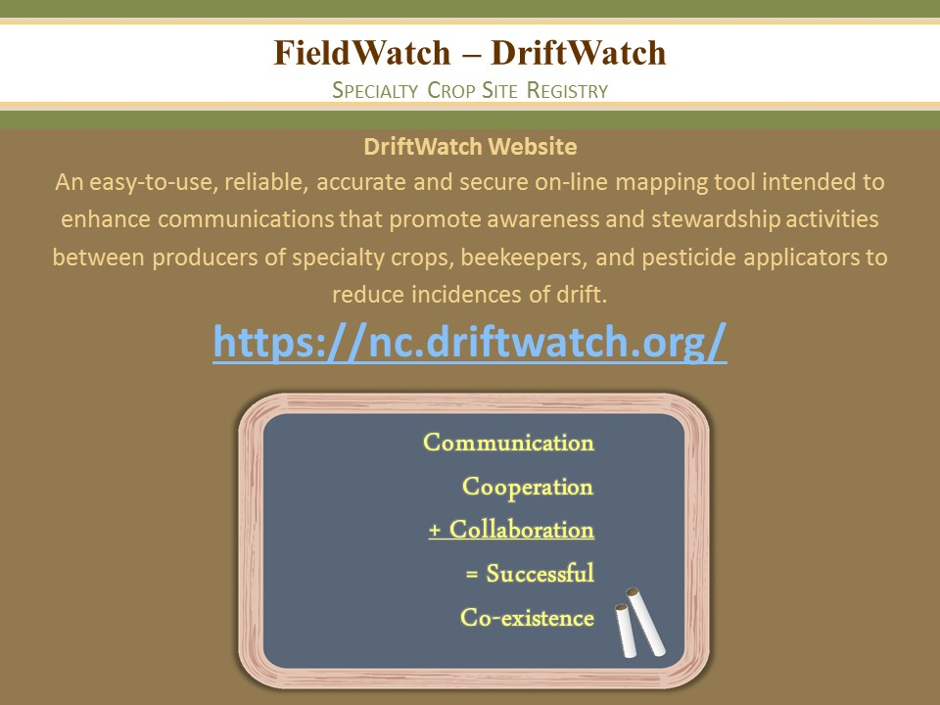

https://driftwatch.org/
The website is very user friendly and can provide a lot of information for beekeepers and applicators alike.
The program is free.

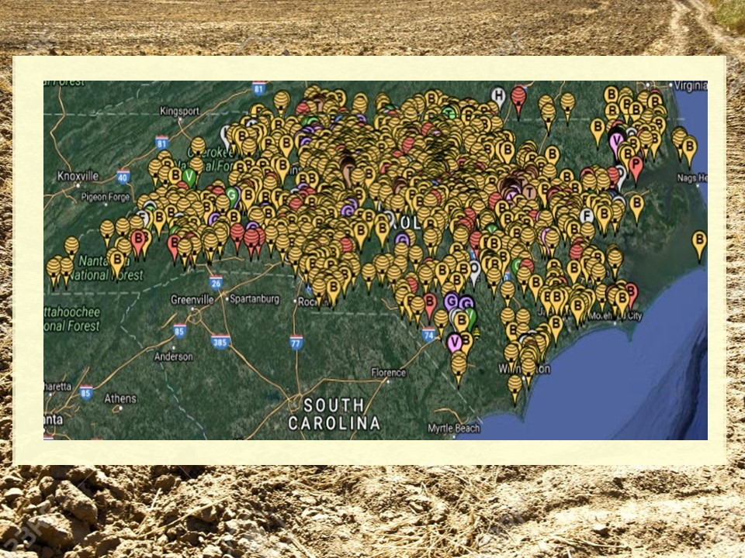

The map of registered Field Watch sites in North Carolina.
Yellow Beehives- more than one hive
Yellow Icon with B-only one hive
Red Beehive- Registered Apiary with Plant Industry, notification of intent to spray by aerial applications when pesticide carrying warning of toxicity to bees on label is to be used within one mile of apiary. Registration Fee $10.00
Red Icon with B- Registered Apiary with only one hive.
Colored Icons such as Purple with a G are Grapes, Orange with P is for Pumpkins, the registered field watch users can click on the ion for specific information.

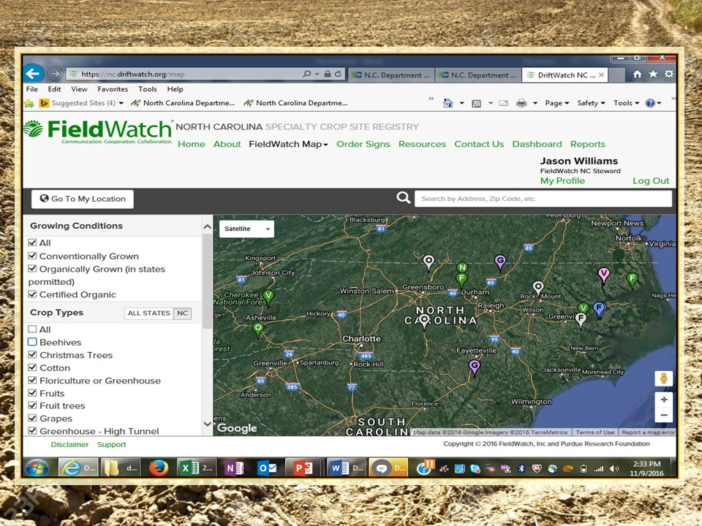

The map can be filtered to see specialty crops and their locations and beehives and apiaries.

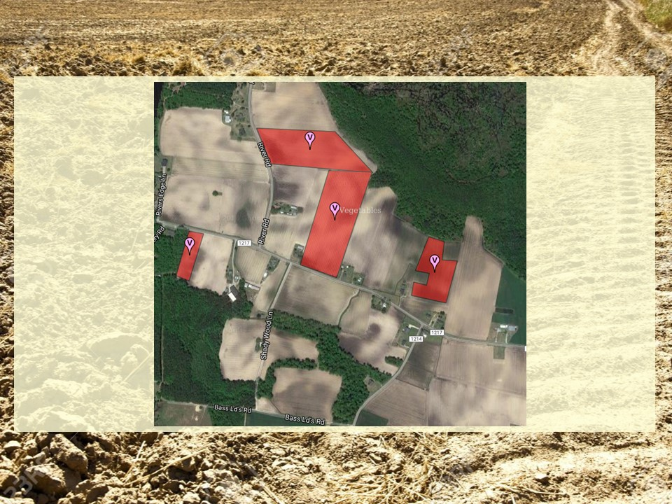

An example of a specialty crop map, this will allow applicators to know the locations of crops that require extra attention when making pesticide applications.

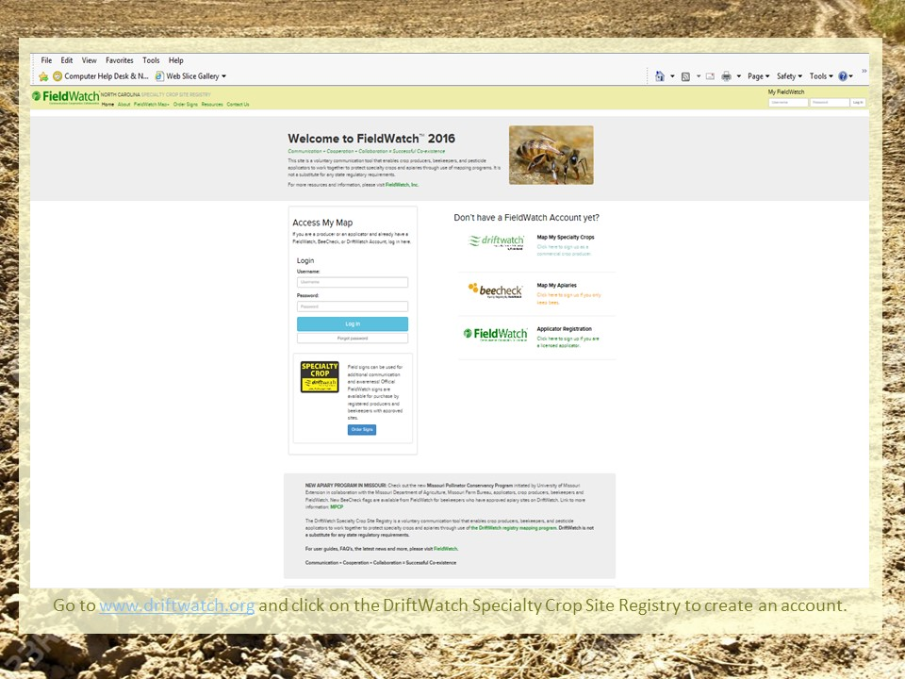

Sign up for the program is easy. Choose the account that is helpful for you and follow the easy to use steps to complete the process.

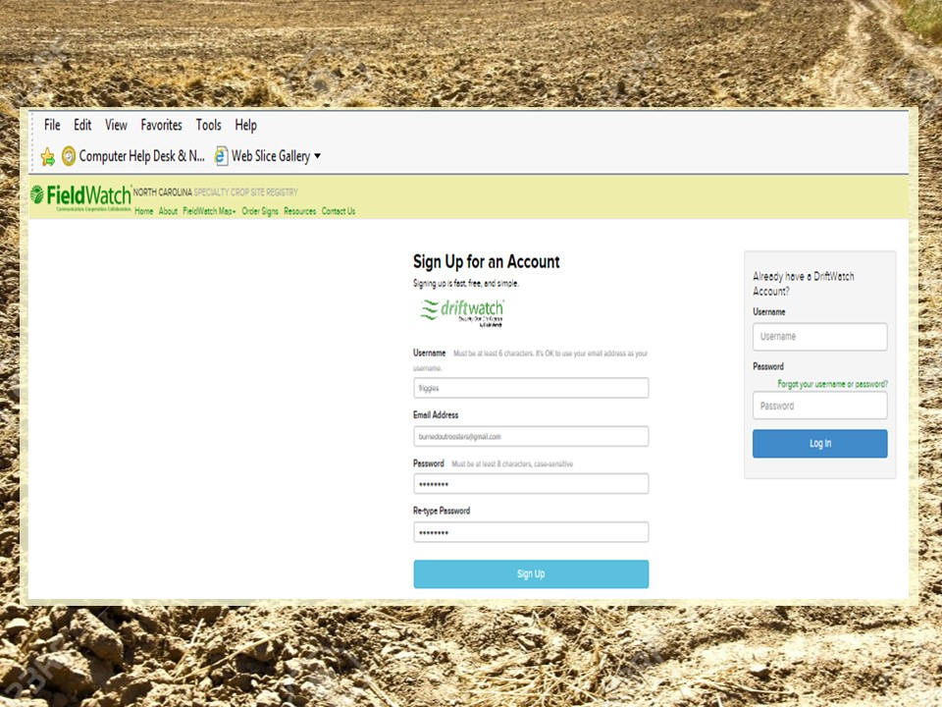

The driftwatch account allows growers of specialty crops to register their crop locations. This tool is very useful in assisting surrounding growers and applicators of the location of crops and their relation to neighbor farms.

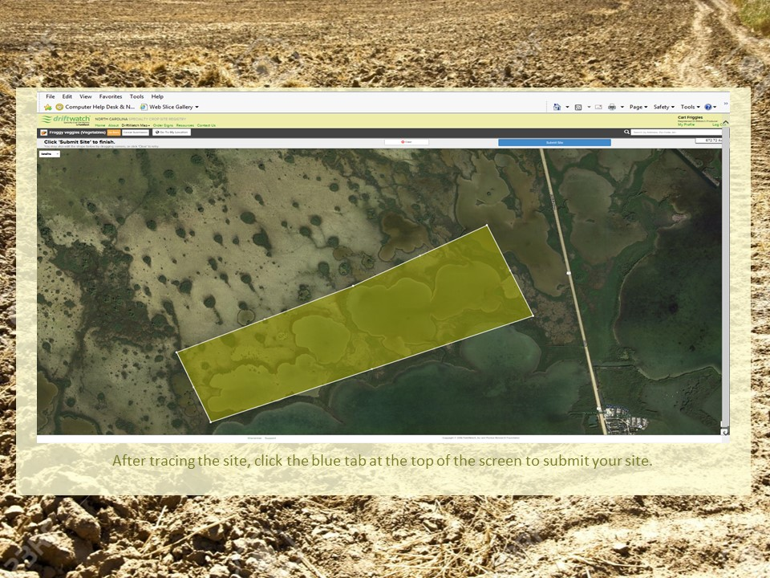

The site allows the grower to mark on the fieldwatch map the location of each specialty crop.

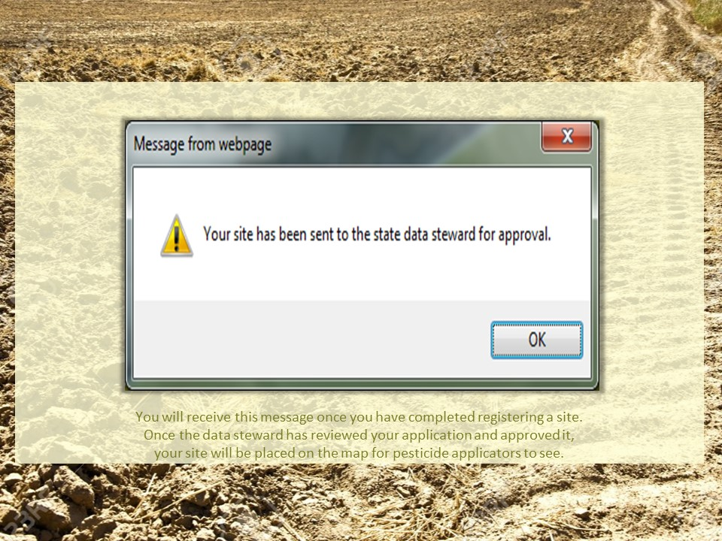

Once the site information is collected and the field location captured the grower will send a request for approval.
For the fieldwatch program to be successful all stakeholders must participate. This allows beekeeper, specialty crop growers and applicators to have the information needed to prevent bee kills and crop adverse effect.

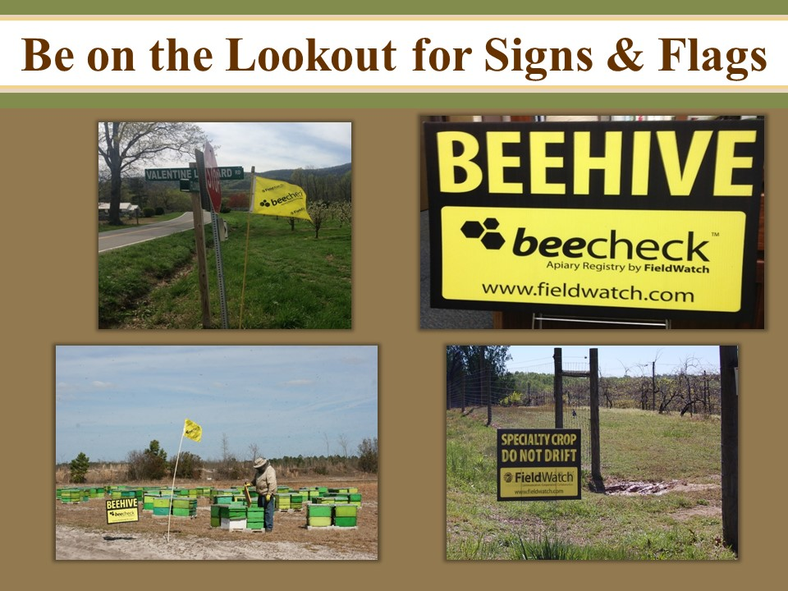

Signs and flags are now available to place near bee yards and specialty crops to alert applicators that special care is needed in these areas during pesticide applications. Signs and flags are available on the Field Watch website.

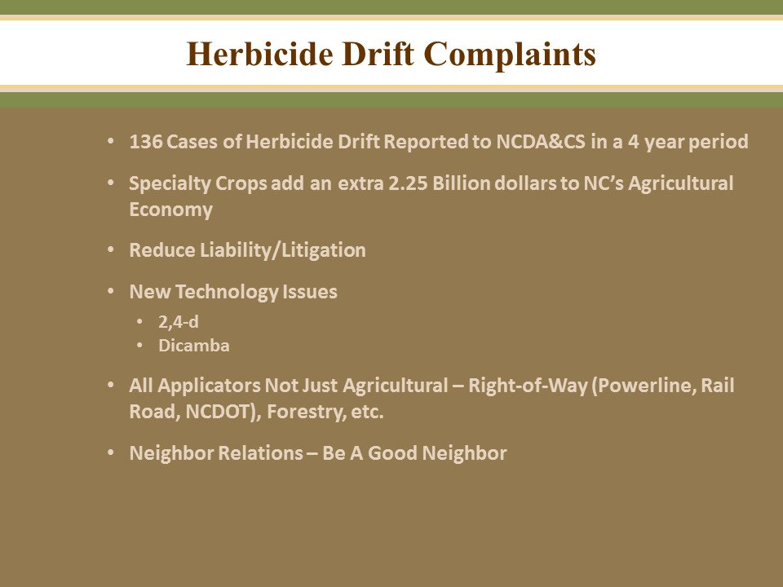

Due to a large number of herbicide drift complaints and concerns about pesticide applications near bee yards the Field Watch program has become very timely. In a state such as North Carolina with the largest number of hobby beekeepers and some of the most diverse specialty crops we must all strive to be good neighbors.

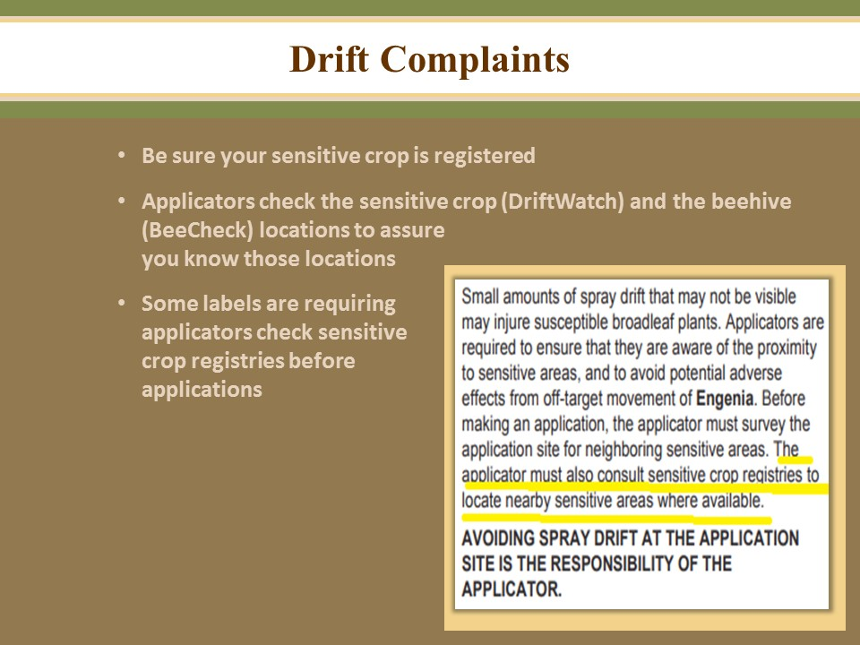

If you grow specialty crops or crops that are sensitive to herbicides be sure your crop is register with the Drift Watch program Growers in your area may not be aware of your crop location. You must also make an effort to be a good neighbor.

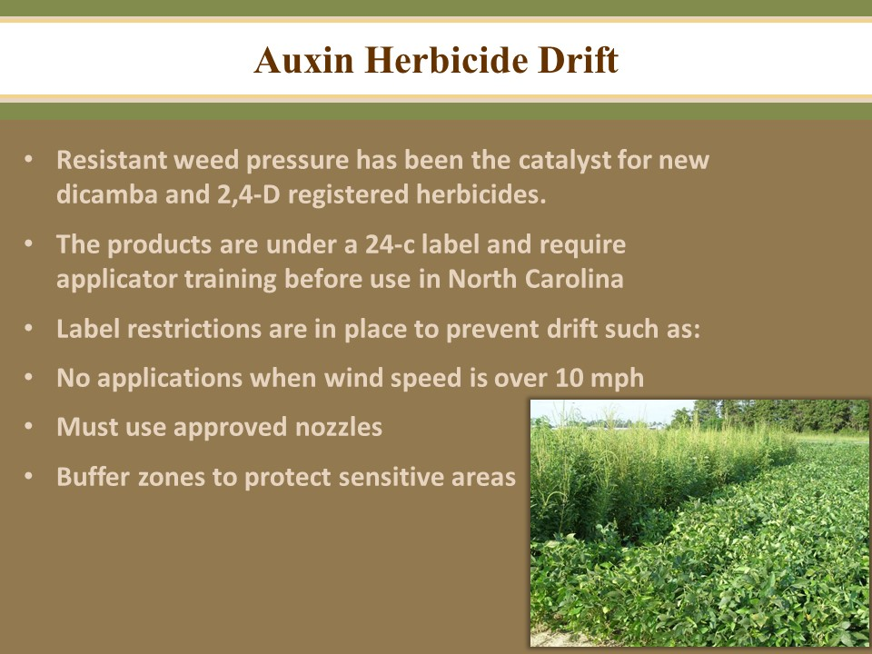

The updated dicamba and 2, 4-D registered products are to be used as a tool against resistant weeds such as Palmer Amaranth. These products can cause herbicide damage to sensitive crops such as tomatoes, grapes, tobacco and non tolerant soybeans and cotton. The additional restrictions are to help applicators be aware of drift possibilities and how to prevent drift issues.

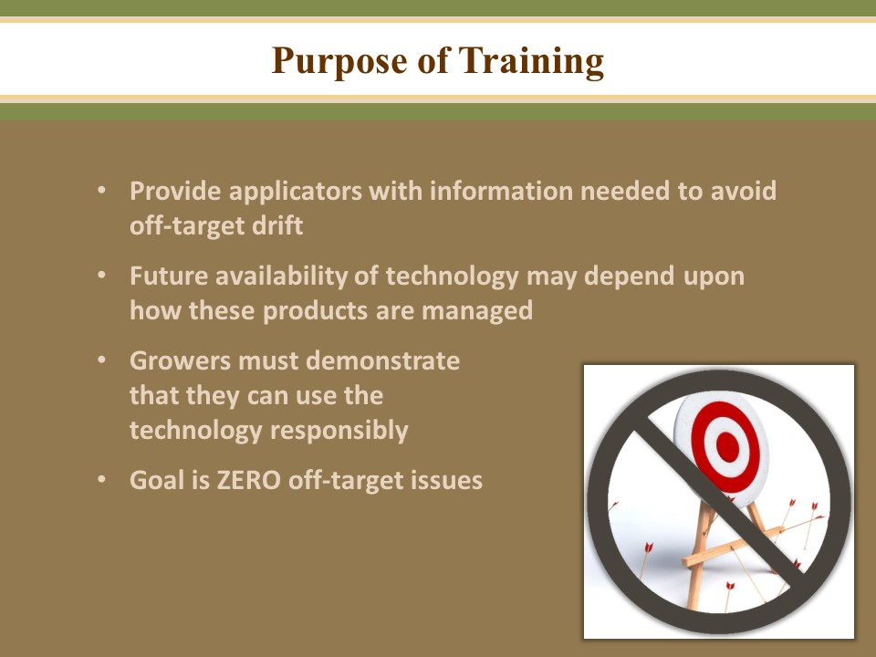

This mandatory training titled Auxin Herbicides – Best Management Practices presented by Dr. Alan York was intended to assist applicators in reducing incidents of herbicide drift to susceptible crops. All applicators will need to complete the training prior to applying these new products.
Training is an annual requirement for any applicator planning to use these auxin products.

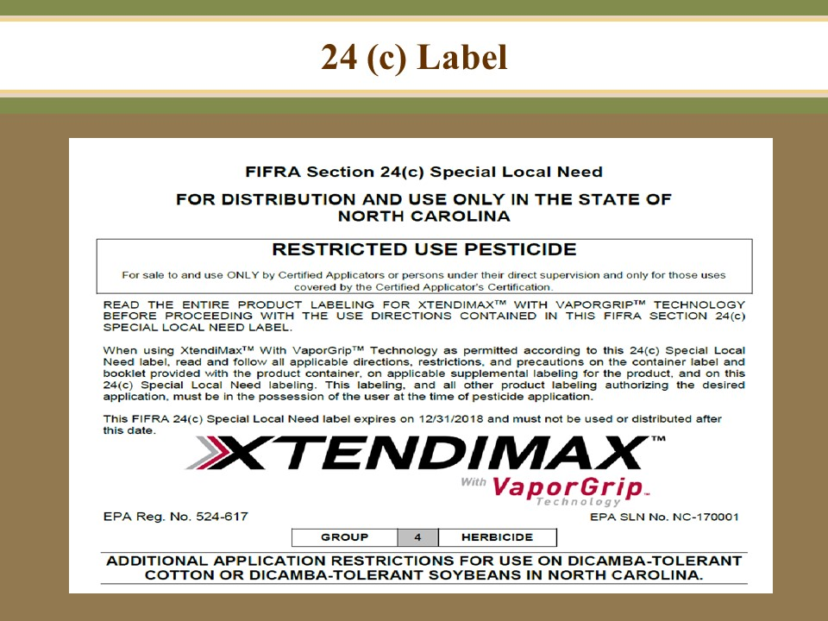

A 24(c) label is in place for growers in North Carolina. The 24(c) label requires specify auxin training for applicators, additional recordkeeping requirements and attention to surrounding crops.
The 24(c) label requires specific mandatory training before making a application to dicamba-tolerant crops. All applicators must complete dicamba or auxin-specific training. Training must be completed annually before each growing season. The annually updated training: “Auxin Herbicides-Best Management Practices” must be approved by the NCDA&CS. Detailed recordkeeping requirements are in place. In addition to the Section 3 label requirements, the 24 c states that records must be completed in 72 hours of the application and include the name of each applicator. Each field application shall be a separate record.
The applicator must have in their possession a copy of the 24(c) labeling for the product being applied. Applicators must also have in their possession complete container labeling that is pertinent to the application. Applicators are responsible for obtaining all necessary labeling and for adhering to all of the directions, restrictions, and precautions found on the labeling.
Special Local Needs (SLN) or Section 24(c)
-24 c Labels: States have authority under FIFRA Section 24(c) to register additional uses for a federally registered pesticide. A Special Local Needs (SLN) label is a type of submission in which a State registers additional uses, under certain conditions, to a federally registered pesticide to meet specific needs (Figure 3). Consequently, SLN registrations are for distribution and use only within a particular State. Section 24(c) uses often include adding application sites, pests, or alternative control techniques to those listed on the federally registered label. A applicator must have the 24(c) label along with the Section 3 label when making an application that is allowed by the information on the Section 24(c) label.

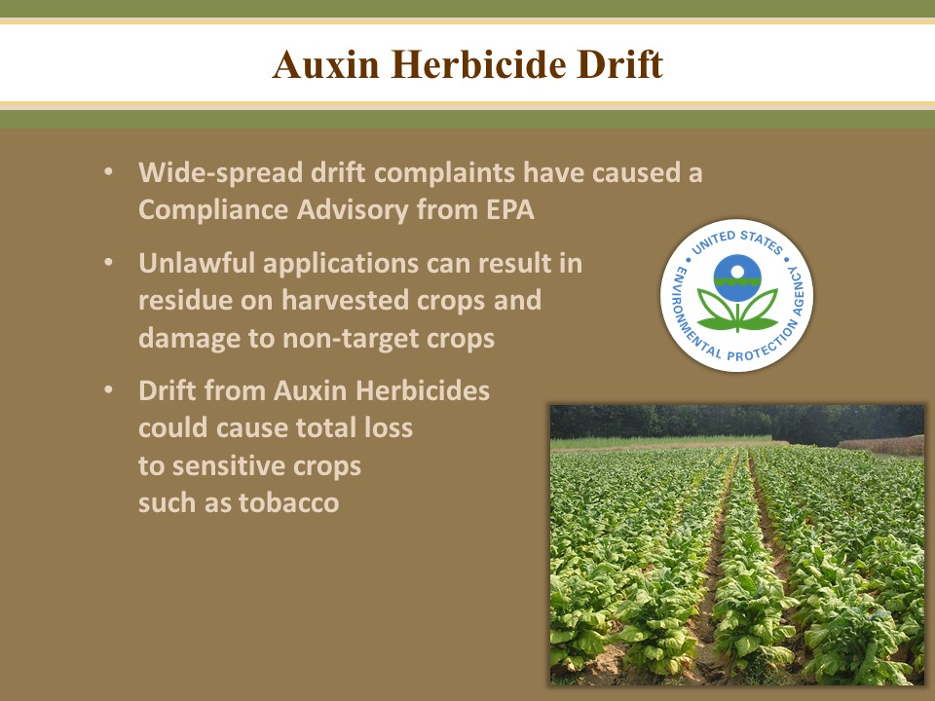

EPA Compliance Advisory Issued July 2017
Late last year, EPA approved the conditional registration of three new dicamba herbicide products for use in-crop (over-top of growing crop plants) as a post-emergent application in Bollgard II XtendFlex cotton and Roundup Ready 2 Xtend soybeans, which are now available for use in the 2017 growing season:
• DuPont FeXapan Herbicide Plus VaporGrip Technology, EPA Registration Number 352-913;
• Engenia Herbicide, EPA Registration Number 7969-345; and
• XTENDIMAX with VaporGrip Technology, EPA Registration Number 524-617.
Agricultural Concerns
Despite the conditional approval of new dicamba products with drift reduction agents and further use restrictions set in place prior to the 2017 growing season, some states are reporting high numbers of dicamba complaints. By early July, there had already been reports of hundreds of complaints received by state agencies in Arkansas, Missouri and Tennessee (a significant increase from last year). Both physical drift and volatilization of dicamba from the target application site
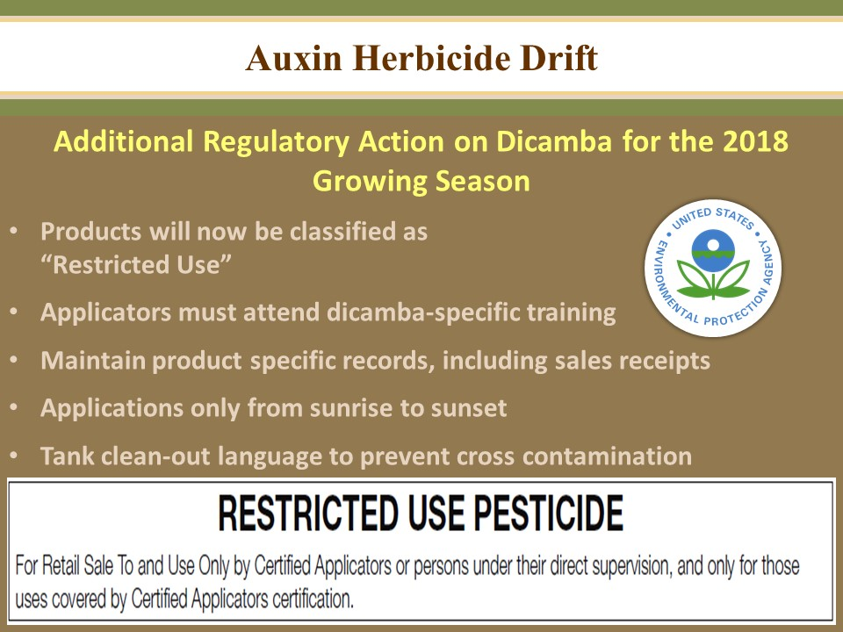

Regulatory Action on Dicamba for 2018
- RUP, Now classified as a Restricted Use Pesticide, permitting only certifies applicators with special training, and those under their supervision with additional training, to apply these dicamba products.
- Applicators working under a private certification must have the special auxin training before making applications.
- Growers are to maintain specific records regarding the use of these products.
1 Full name of the certified applicator
2 Certification number
3 EPA registration number
4 Amount applied
5 Application month, day, year
6 Location of application
7 Crop or site receiving the application
8 Size of area treated
9 Proof of training requirements
10 Application Timing
11 Receipts of purchase
12 Product Label, including 24 (c) labels and supplements
13 Sensitive crops awareness
14 Spray System Cleanout, show compliance with the spray system equipment clean-out section of the label
15 Tank mix products
16 Start and finish times
17 Nozzle selection
18 Air temperature
19 Wind speed and direction
Keep in mind recordkeeping requirements are specific to each label. Be sure to read the label of the product being used for recordkeeping requirements.

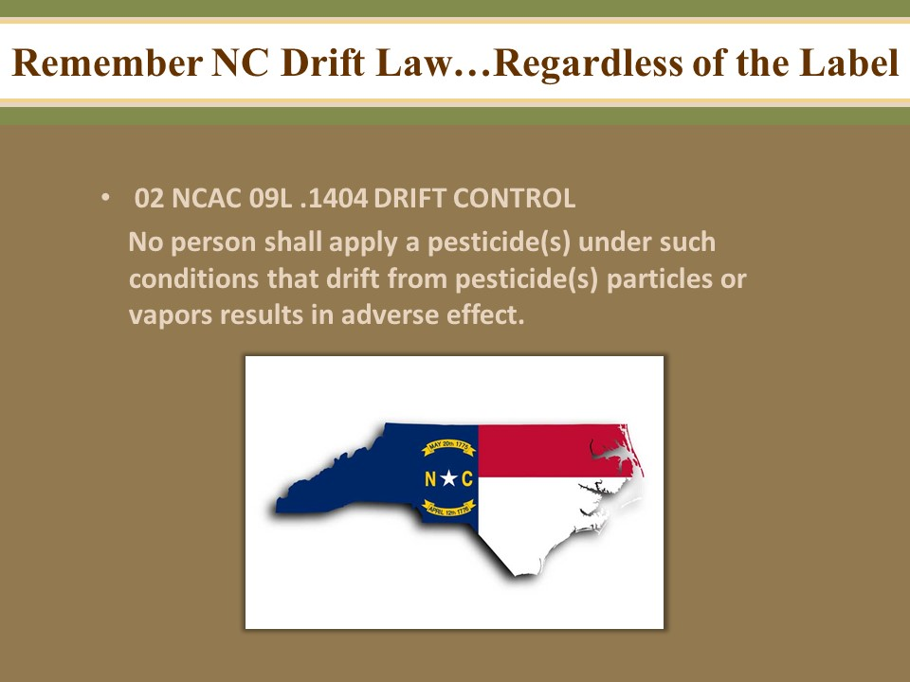

North Carolina Pesticide Rules and Regulations
02 NCAC 09L .1404 DRIFT CONTROL
No person shall apply a pesticide(s) under such conditions that drift from pesticide(s) particles or vapors results in adverse effect.

History Note: Authority G.S. 143-458; 143-463;
Eff. August 1, 1985.

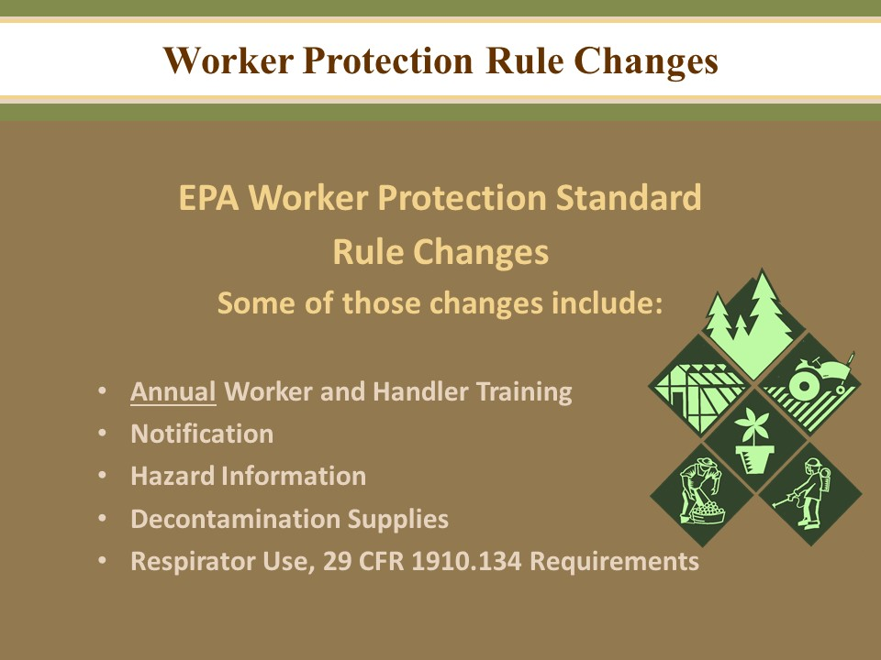

The revised WPS rule is in effect at this time. Changes could be coming in the future.

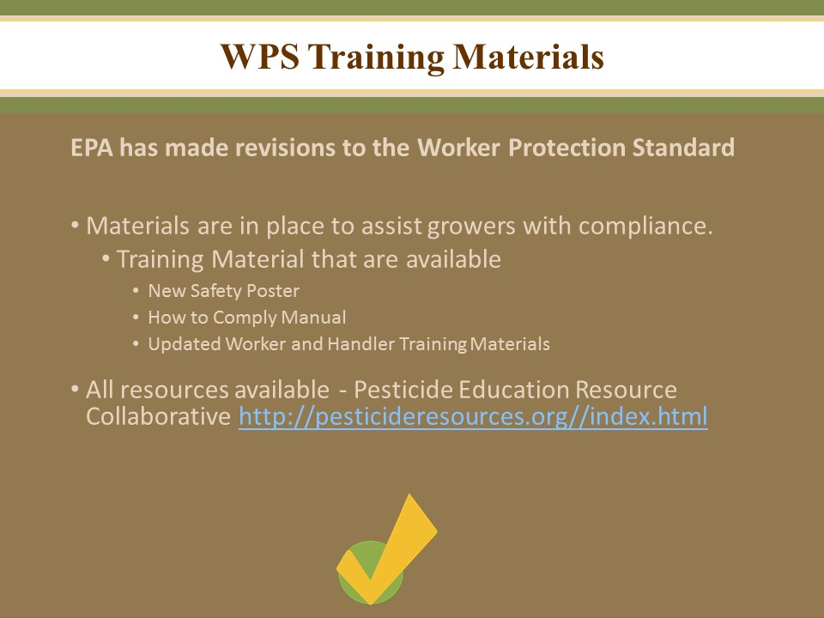

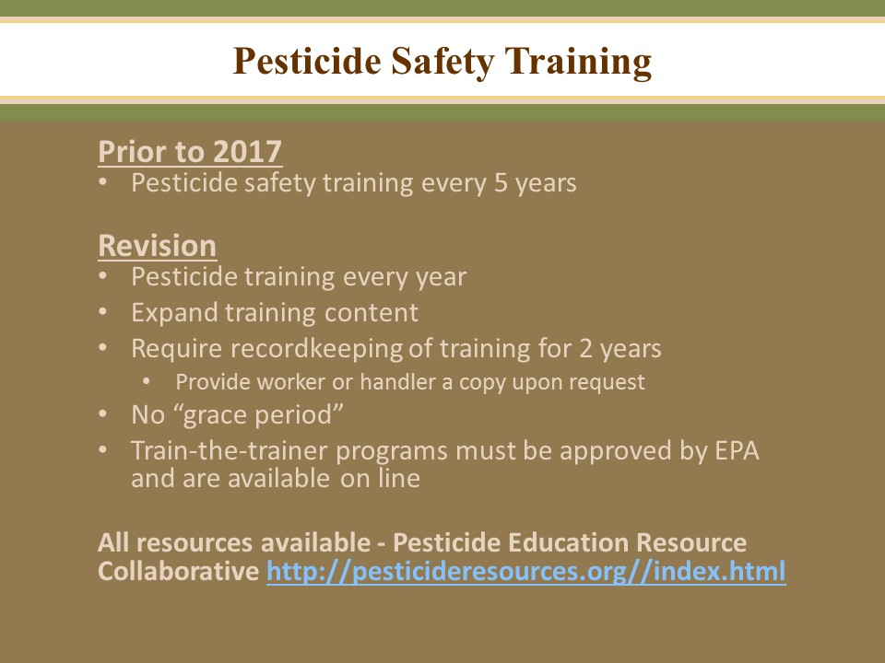

Pesticide Safety Training
All workers and handlers employed by an agricultural employer must receive annual WPS training as a worker or as a handler (except as provided for in the exemptions or exceptions).
There is no grace period for WPS training.
The agricultural employer must ensure that WPS training is completed within the last 12 months before:
-Any worker enters a treated area on an agricultural establishment where, within the last 30 days, a WPS-labeled pesticide product has been used or a REI for such pesticide has been in effect.
-Any handler conducts any handling task.
Worker and handlers are exempt from WPS training if they are currently:
-Certified as an applicator of restricted-use pesticides.
-Certified as a crop advisor by a program acknowledged as appropriate in writing by EPA, or a State or Tribal agency responsible for pesticide enforcement.
Additionally, a worker is exempt from WPS worker training if they have been trained as a WPS handler within the last 12 months.
Only qualified trainers may provide WPS training
Train workers and handlers annually
Provide training in a manner that the workers or handlers can understand, using a translator if necessary.
Present training using EPA-approved materials either orally from written materials or audio-visually
Keep records of worker or handler training for 2 years.
Make training records available to employees upon request.

Pesticide Safety Training
All workers and handlers employed by an agricultural employer must receive annual WPS training as a worker or as a handler (except as provided for in the exemptions or exceptions).
There is no grace period for WPS training.
The agricultural employer must ensure that WPS training is completed within the last 12 months before:
-Any worker enters a treated area on an agricultural establishment where, within the last 30 days, a WPS-labeled pesticide product has been used or a REI for such pesticide has been in effect.
-Any handler conducts any handling task.
Worker and handlers are exempt from WPS training if they are currently:
-Certified as an applicator of restricted-use pesticides.
-Certified as a crop advisor by a program acknowledged as appropriate in writing by EPA, or a State or Tribal agency responsible for pesticide enforcement.
Additionally, a worker is exempt from WPS worker training if they have been trained as a WPS handler within the last 12 months.
Only qualified trainers may provide WPS training
Train workers and handlers annually
Provide training in a manner that the workers or handlers can understand, using a translator if necessary.
Present training using EPA-approved materials either orally from written materials or audio-visually
Keep records of worker or handler training for 2 years.
Make training records available to employees upon request.

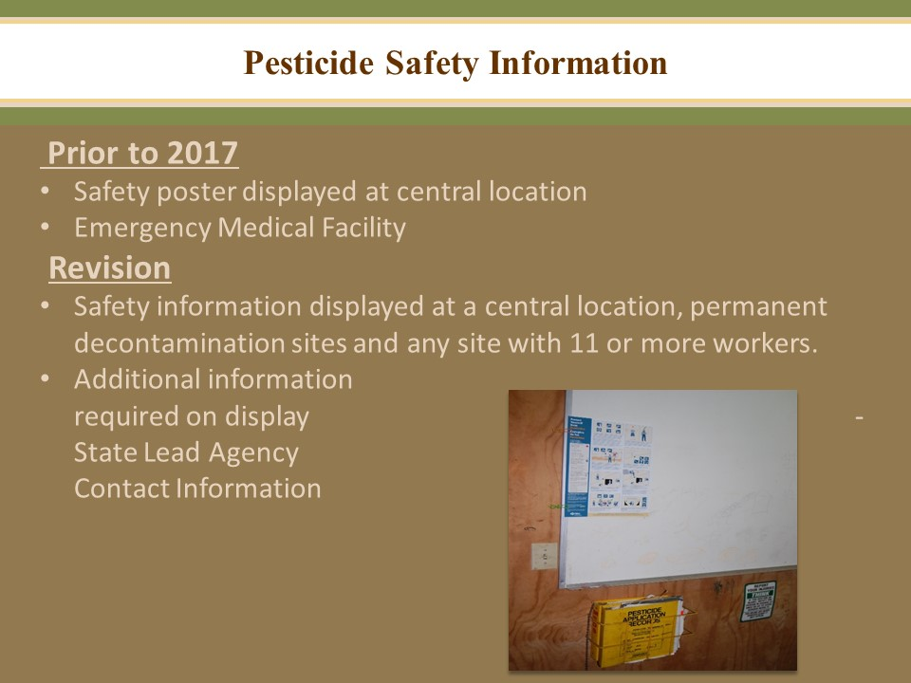

Central Location
Pesticide safety, application, and hazard information must be displayed at a central location on an agricultural establishment that is readily accessible at all times during normal work hours and can be easily seen and read by workers and handlers.
-Pesticide safety information can be a poster developed by EPA, or an equivalent
-Pesticide application information including:
Name of the pesticide applied
Active ingredient
EPA registration number
REI
Crop or site treated
Location and description of the treated area
Date and times application started and ended
-Hazard Information, consists of a copy of the OSHA Safety Data Sheet (SDS) for each pesticide product.
-In addition only pesticide safety information (poster) must be displayed at:
Any permanent decontamination site, and
Any location where decontamination supplies are required in quantities for 11 or more workers.

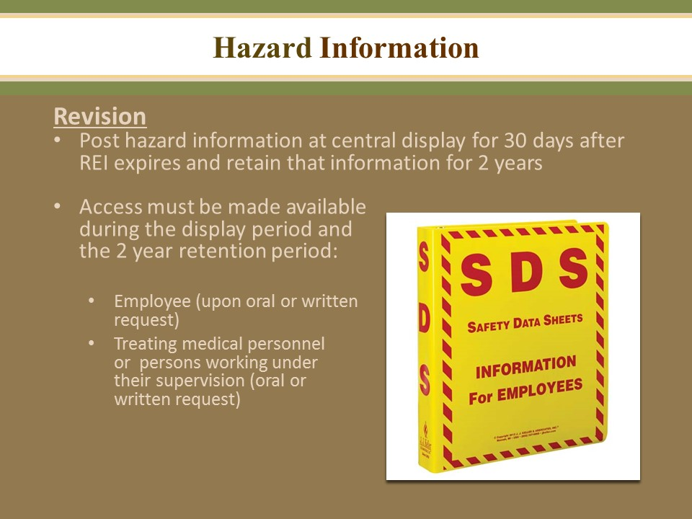

Hazard information consists of a copy of the OSHA Safety Data Sheet (SDS) for each pesticide product.
The SDS can be kept electronically, however the worker and handlers must have a way to have unrestricted access to the information at all times during their work hours and must be trained on how to access the information.
Workers and Handlers may request a copy of the pesticide application and hazard information if:
-The person was employed as a worker or handler by the establishment during the period when the information was to be displayed and maintained.
-The request cab be made orally or in writing
Treating medical personnel may request access to a copy of pesticide application and hazard information for the diagnosis or treatment of a worker or handler that was employed at the establishment during the application period.
Information must be provided within 15 days of the request.

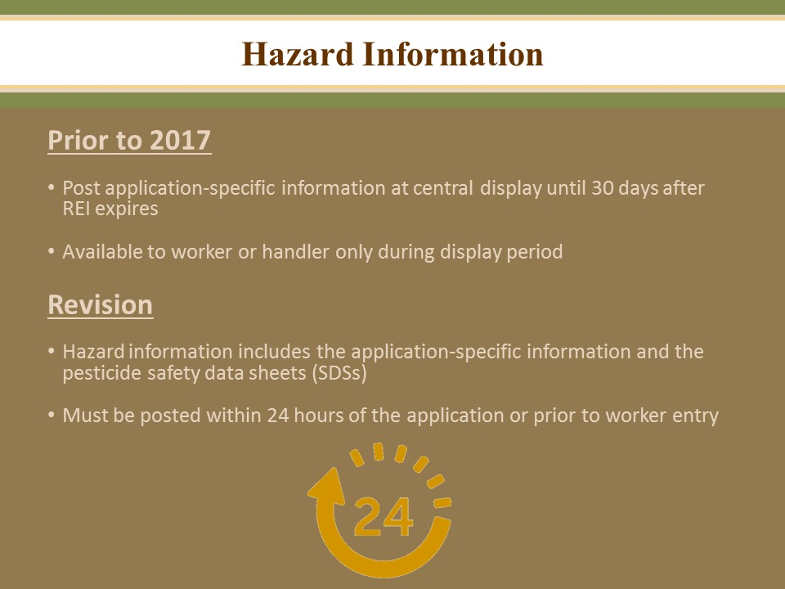

The agricultural employer must keep a record of the pesticide application and hazard information on the establishment for 2 years from the expiration date of the REI of the pesticide applied.

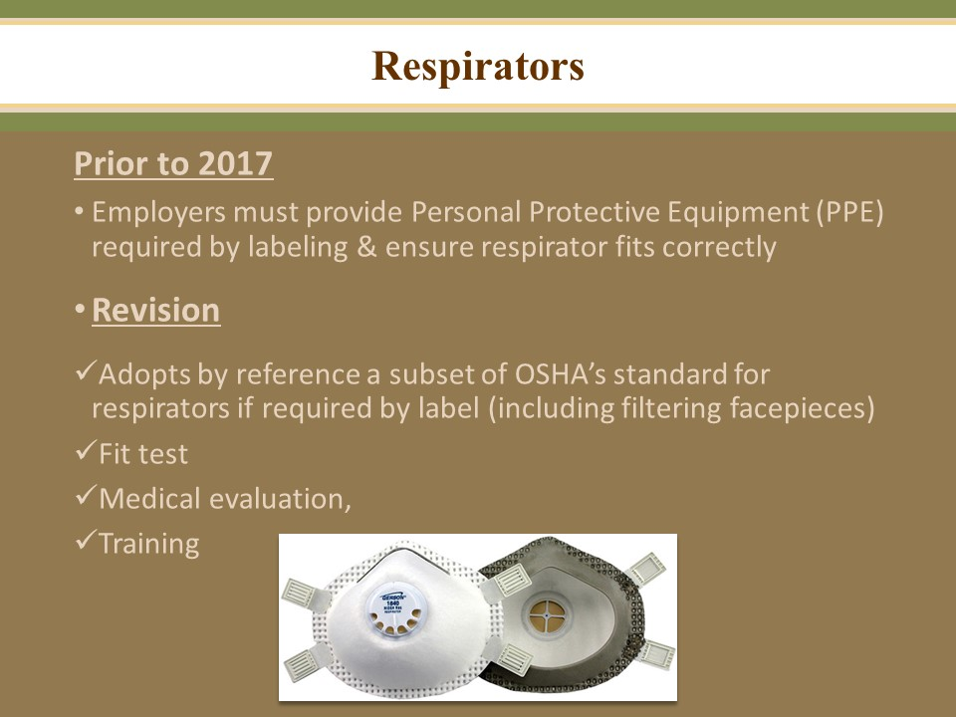

The WPS adopted certain Occupational Safety and Health Administration (OSHA) provisions that require handler employers to provide medical evaluation, fit testing ,and training to handlers when using a pesticide product that require use of a respirator.
Whenever a respirator is required to be worn by the pesticide product labeling, the correct respirator specified by the label must be used. Prior to using a respirator, the handler employer must provide the handler with the following:
Medical evaluation
Annual fit testing, and
Annual respirator training
The handler employer must keep records of the medical determinations (proof of medical evaluations), fit testing and respirator training for 2 years from the date conducted.

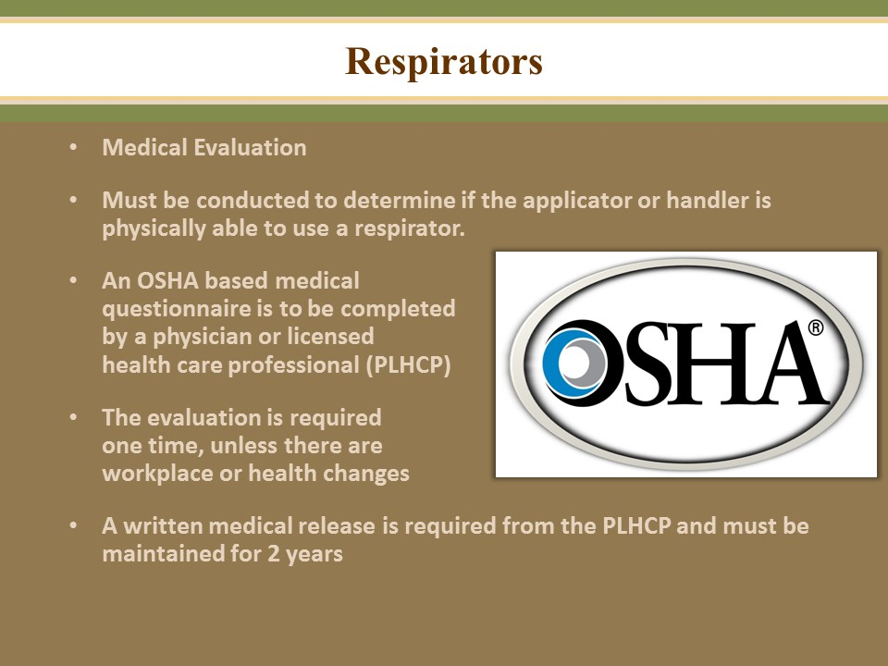

Medical evaluation
Using a respirator may place a physiological burden on handlers that could cause injury if the wearer has certain health problems or medical conditions. This burden varies with the type of respirator worn, the job and conditions in which the respirator is used, and the medical status of the handler.
A medical evaluation must be conducted to determine whether the handler is physically able to use a respirator before the handler is fit tested or required to use the respirator.
The handler employer must identify a physician or other licensed health-care professional (PLCP) to perform the confidential medical evaluation using a medical questionnaire or exam. The medical evaluation must be done at no cost to the employee. The questionnaire may be provided by the PLCP and must be based on OSHA’s Part A of Appendix C to 1910.134.
The medical evaluation is required one time unless:
-The evaluation (medical release) is only good for a specified length of time, such as 1 year.
-The employee reports medical signs or symptoms related to respirator use.
-The PLHCP, a supervisor, or the program administrator recommends a re-evaluation.
-Fit-test or other program information indicates a need for re-evaluations
-When changes in the workplace increase respiratory stress on and employee.
-The initial medical examination demonstrates the need for a follow-up medical examination.
Documentation
The PLHCP will send the handler employer and the handler a written medical determination (medical release) of the medical evaluation results.
Recordkeeping
Maintain a copy of the written medical determination for at least 2 years, or until a subsequent medical evaluation is conducted.

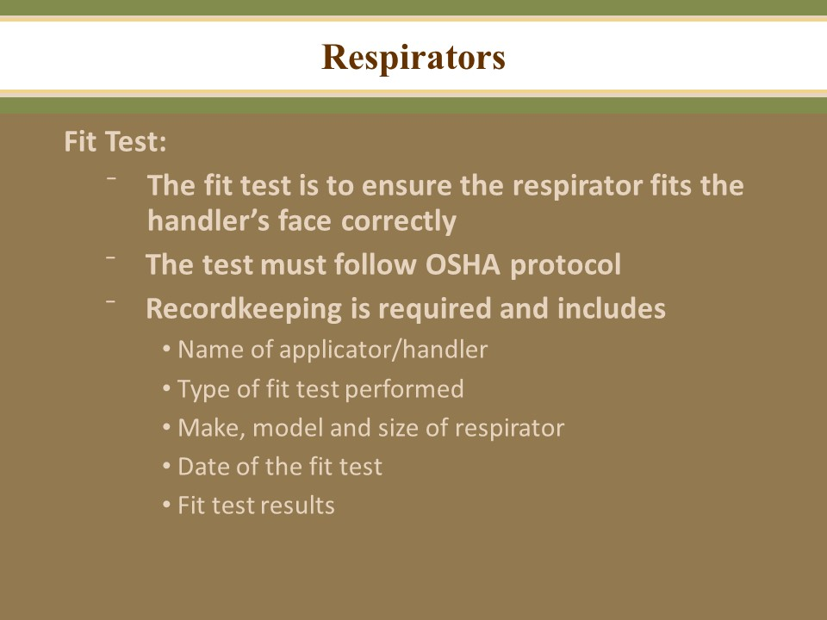

Annual Fit Test
The purpose of a fit test is to ensure that the respirator forms an adequate seal with a handler’s face so the respirator provides the intended inhalation exposure protection.
The fit test must be conducted using the exact make, model, style and size of respirator that the handler users.
Fit testing must follow OSHA protocols,

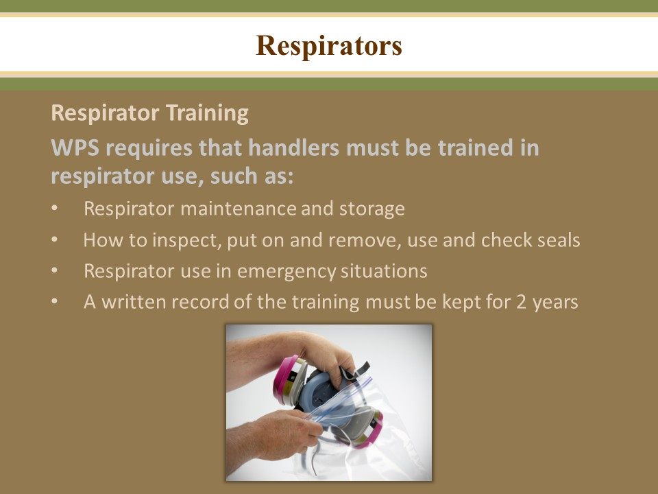

Annual respirator training
Handlers must be provided with training in the use of the respirator specified on the pesticide product labeling and demonstrate knowledge of the following:
-Why the respirator is necessary and how improper fit, usage, or maintenance can compromise the protective effect of the respirator.
-What the limitations and capabilities of the respirator are,
-How to select cartridges and canisters and know the schedule for changing,
-How to use the respirator effectively in emergency situations, including situations in which the respirator malfunctions,
-How to inspect, put on and remove, use, and check the seals of the respirator
-Respirator maintenance and storage procedures, and
-How to recognize medical signs and symptoms that may limit or prevent the effective use of respirators
-
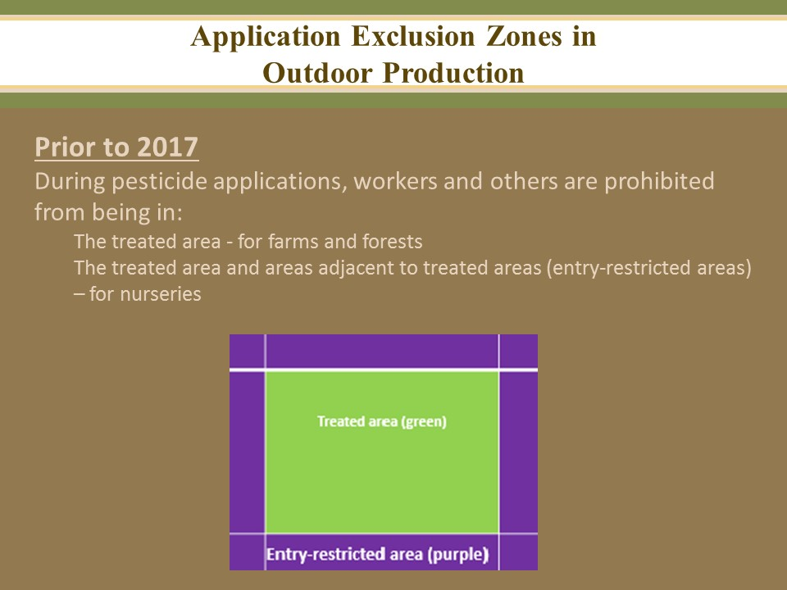

Restrictions During and after Applications
During Applications:
Keep everyone except appropriately trained and equipped handlers out of areas being treated with pesticides
In nurseries and greenhouses, during some applications, also keep workers and other persons out of the area immediately around the area being treated. The size of this “keep-out zone” depends on the pesticide used and the application method.

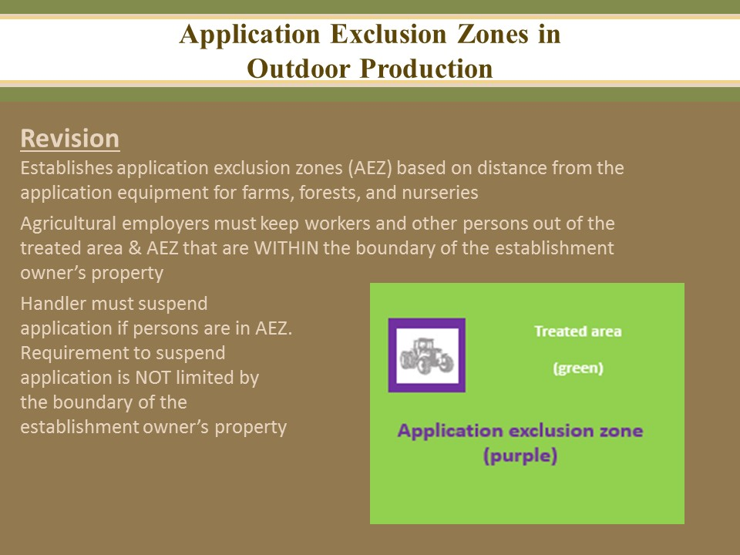

Entry restrictions for outdoor production-application exclusion zone (AEZ)
The AEZ is a zone or area surrounding pesticide application equipment that exists only during outdoor production pesticide applications.
-When applications of WPS-labeled pesticide products are in progress on their establishments, agricultural employers must not allow or direct any worker or other person, to enter or to remain in the treated area or the AEZ that is within the boundaries of the establishment.
-After the application is complete, the AEZ no longer exists and the treated area is subject to the REI specified on the pesticide product labeling and to the relevant WPS restrictions after applications.
Suspend pesticide applications
-The handler requirement to suspend the application applies if a worker or other person is in any portion of the AEZ. In this situation , the applicator must temporarily suspend the application and may not proceed until the applicator can ensure that the pesticide will not contact any persons that are in the AEZ, including areas that extend beyond the boundary of the establishment.

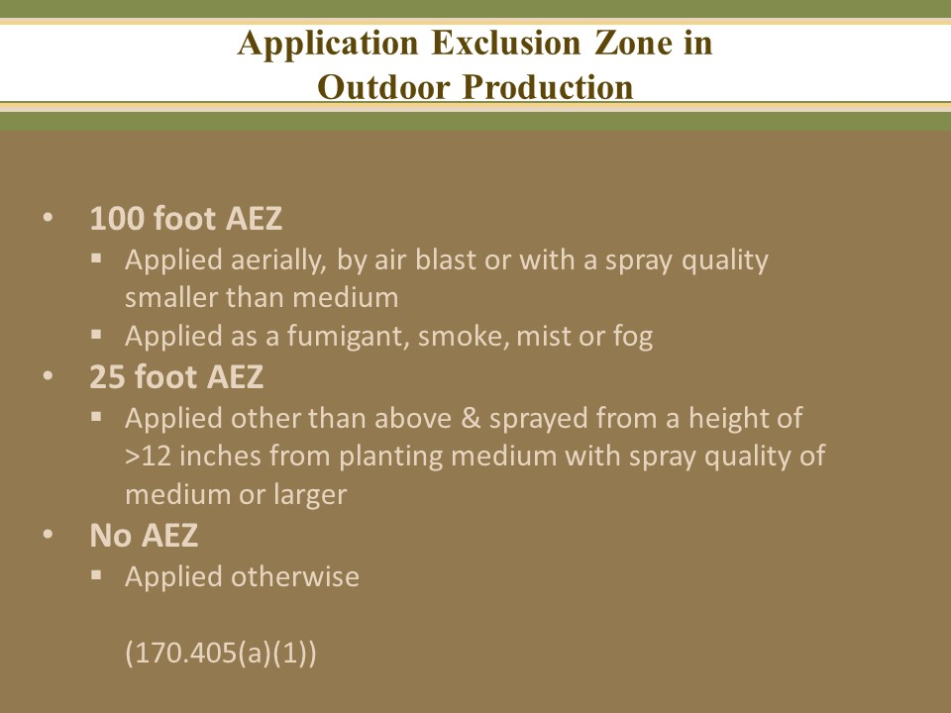

Size of the application exclusion zone (AEZ)
The size of the AEZ is determined by the application method and spray quality.

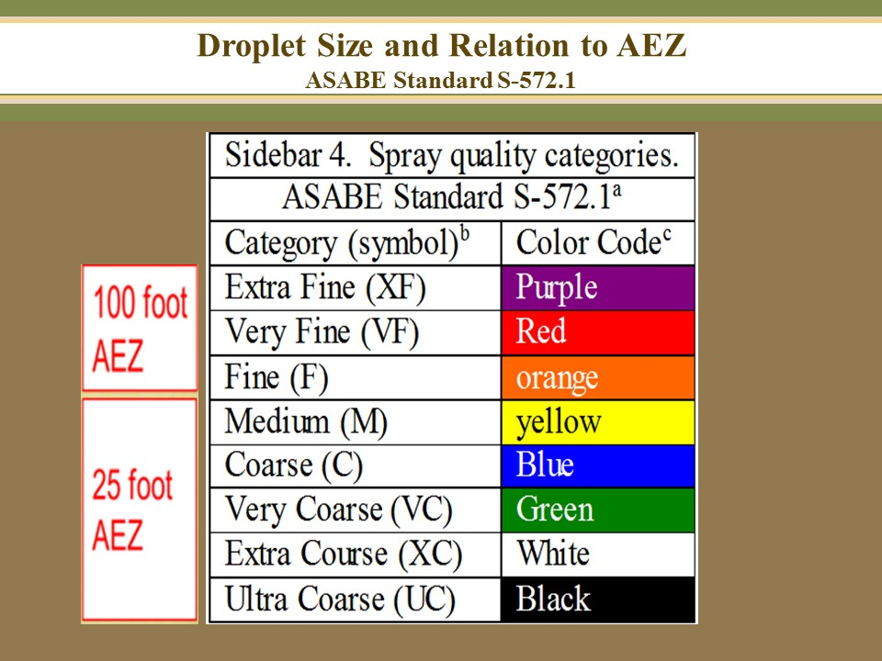

Size of the application exclusion zone (AEZ)
The size of the AEZ is determined by the application method and spray quality.
-Spray quality (defined by the American Society of Agricultural and Biological Engineers Standard (ASABE) S-572.1) considers several factors including the nozzle design, system pressure, and speed of the application equipment.
-Measure the AEZ starting from each dispersion point or nozzle on the pesticide application equipment and extend horizontally in all directions.
-Situations where no AEZ is required include applications of granular pesticides, soil-incorporated pesticides (not fumigants); pre-plant, at-plant, and spot-spray pesticide applications as long as they are less than 12 inches from the soil and use a medium or larger spray quality.

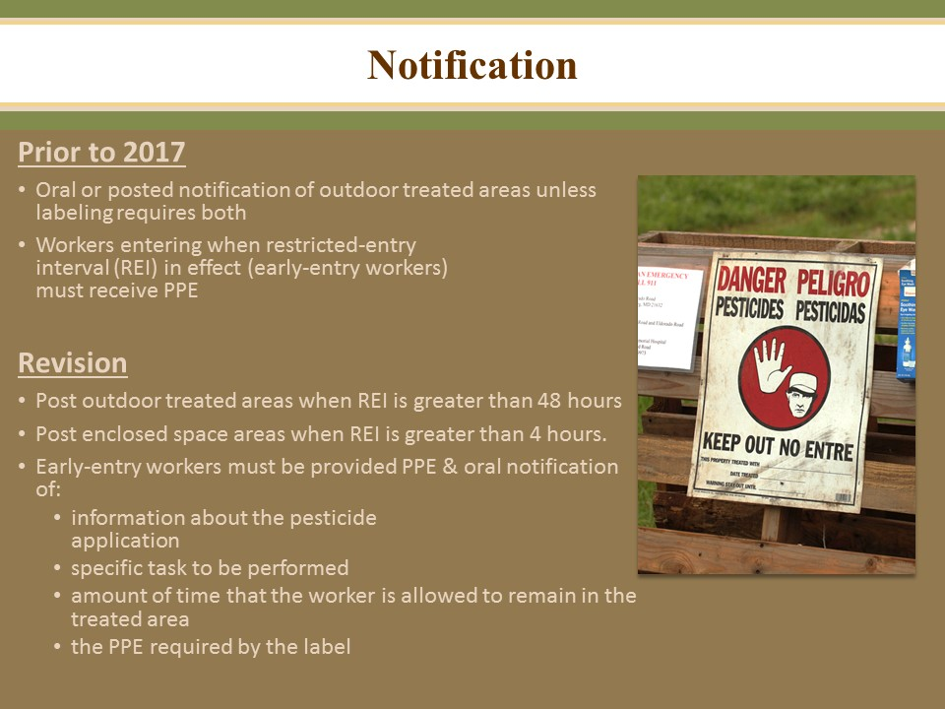

Notification of Entry Restrictions
To inform workers of where pesticide applications have taken place on an agricultural establishment and of the entry restrictions for each situation, the agricultural employer must notify workers of restrictions to keep workers out of a treated area for a specified period of time.
Post warning signs:
If a pesticide is applied to an outdoor production area and the product labeling requires a REI greater than 48 hours, then workers must be notified of the application by posting warning signs.
If a pesticide is applied to an enclosed space production area and the product labeling requires a REI greater than 4 hours, then workers must be notified of the application by posting warning signs.

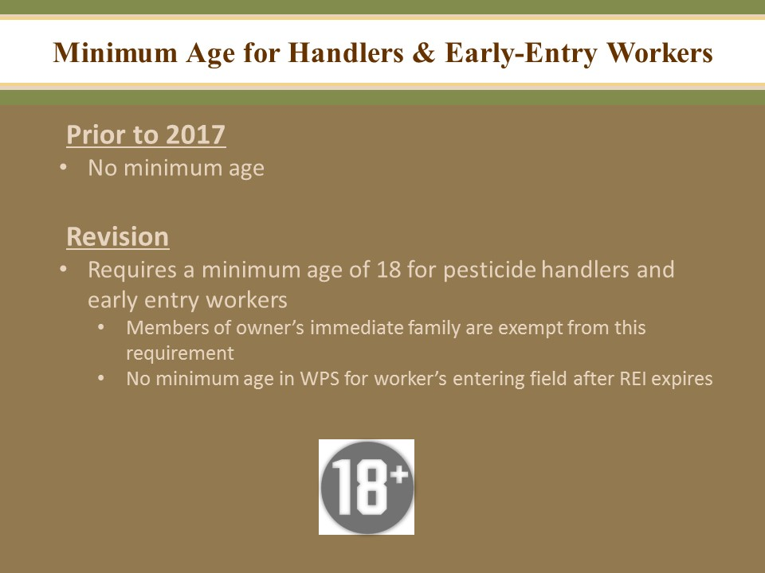

The minimum age of 18 years old applies to all handlers and early-entry workers at agricultural establishments including research facilities, universities, or governmental entities. The only exemption form the minimum age is for owners of agricultural establishments and their immediate family.

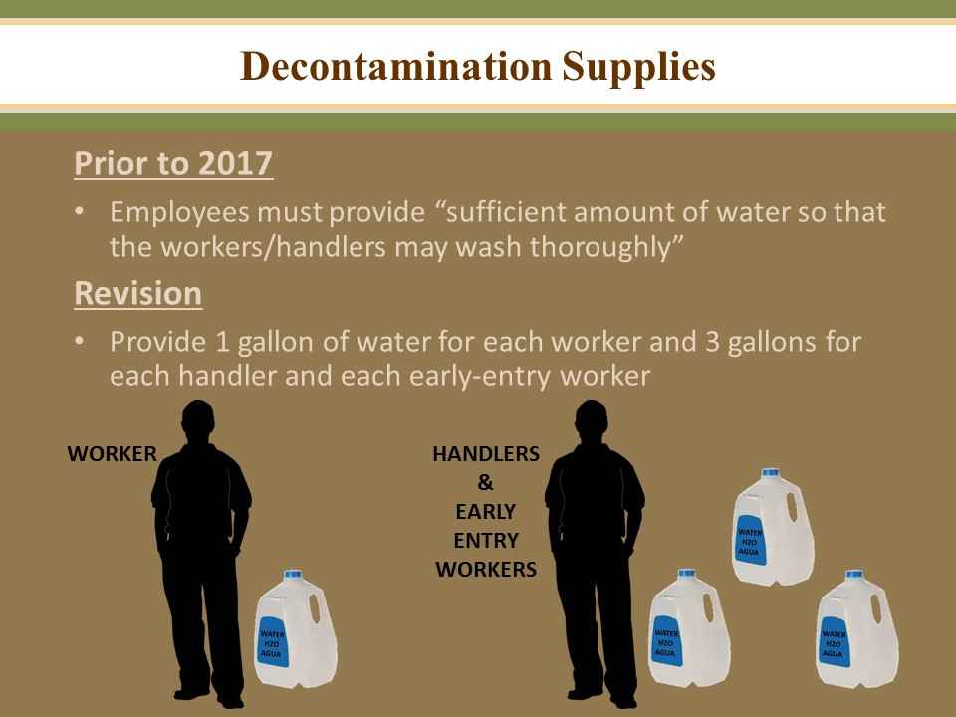

Decontamination Supplies for Workers
Agricultural employers of workers must make sure that decontamination supplies are provided to workers who are working in a pesticide-treated area where, within the last 30 days, a WPS-labeled pesticide product has been used or a REI for such pesticide has been in effect, and are doing tasks that involve contact with anything that has been treated with the pesticide, including soil, water, or plants.
Decontamination supplies must be provided for workers:
If the REI is greater than 4 hours, provide the decontamination supplies until 30 days after the end of the REI
If the REI is less than or equal to 4 hours, provide the decontamination supplies until 7 days after the REI expires.
Supplies that must be provided to workers:
Water- The agricultural employer must provide at least 1 gallon of water for each worker at the beginning of the work period. The water must be a quality and temperature that will not cause injury or illness if it contacts skin or eyes, or is swallowed. If a water source is used for mixing pesticides, it cannot be used for decontamination without taking additional precautions to prevent contamination of the water by pesticides.
Soap and single use towels- enough for workers’ needs. Hand sanitizers or wet towelettes do not meet the requirement for soap or towels.
Decontamination supplies for Handlers
Supplies must be provided for the duration of the handling task and until PPE is removed.
3 gallons of water or more per handler is required at the start of the work period.
A clean change of clothes, such as one-size-fits-all coveralls, to put on if the handlers’ clothes are contaminated and need to be removed right away.
Decontamination supplies including water for routine cleaning, soap, single use towels and change of clothes must be located together and must be:
-Reasonably accessible to handlers (within ¼ mile or at the nearest vehicular access),
-Outside of any treated area or an area under a REI unless supplies are all contained within a pesticide protected closed containers.
-At any mixing or loading site, and
-At the site where PPE is removed.

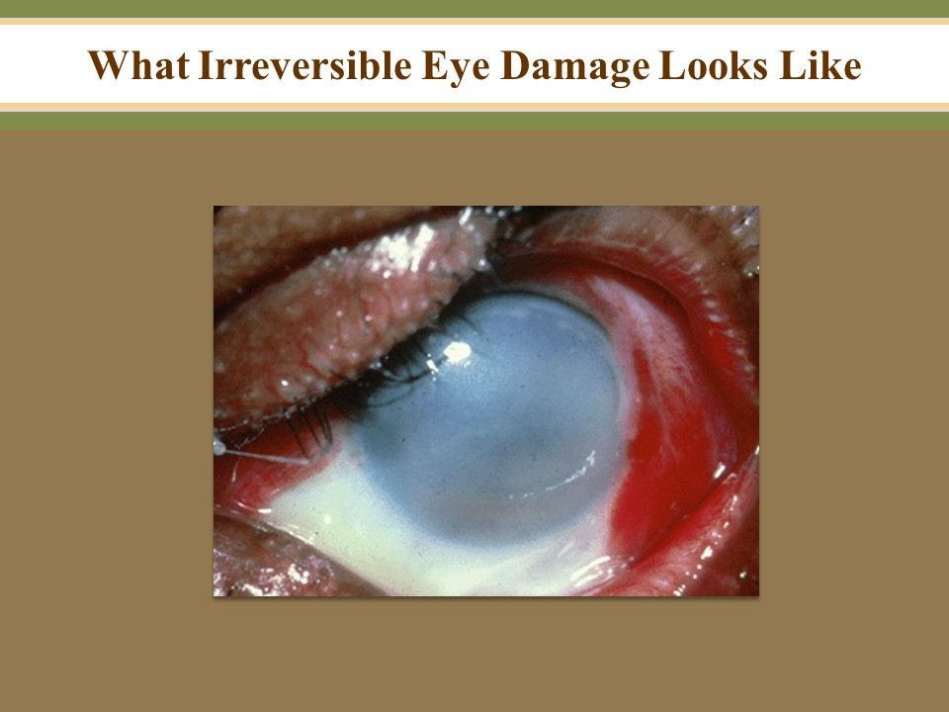

Yikes!

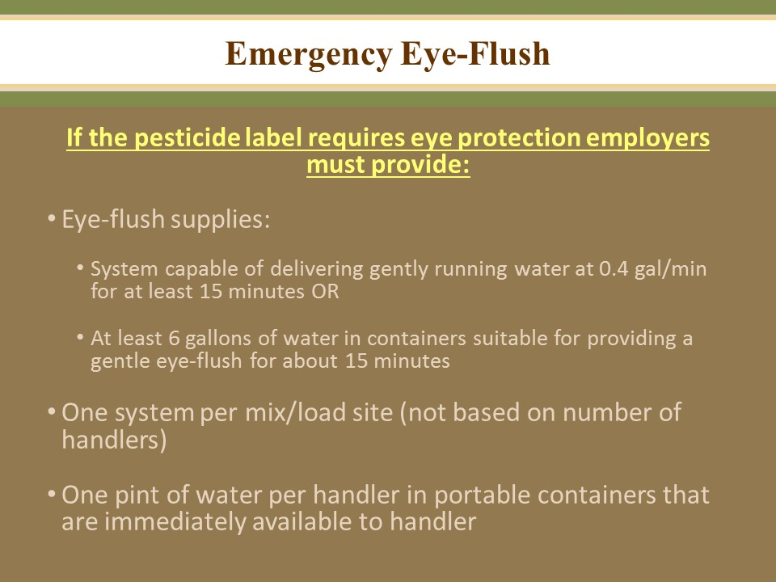

Emergency eye flushing station:
Emergency eye flushing supplies must be provided at any site where handlers are mixing or loading a pesticide that requires protective eyewear or are mixing or loading any pesticide using closed system operating under pressure.
Supplies that must be available are
-A system capable of delivering gently running water at a rate of at least 0.4 gallons per minute for at least 15 minutes, or
-At least 6 gallons of water in containers suitable for providing gently running water for eye flushing for 15 minutes. The container(s) must be able to dispense a gentle steady flow of water.
This requirement was included in the previous rule (1992). When applying a pesticide that requires protective eyewear, 1 pint of water must be immediately available to each handler in a portable container.

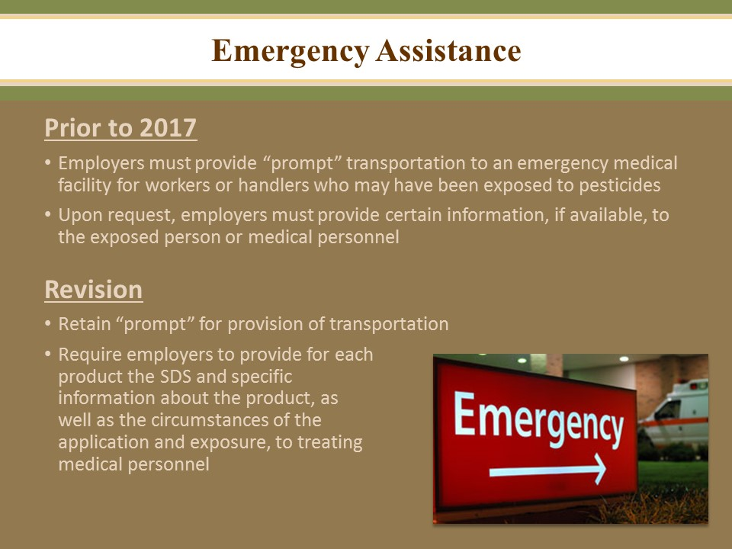

Emergency Assistance
The agricultural employer must provide transportation and emergency information promptly for their workers after learning of possible poisoning or injury.
Employers can make transportation available by:
-Taking the employee to the medical care facility,
-Calling an emergency vehicle, such as an ambulance
-Making sure the employee has a ride to the medical care facility with someone else.
Provide the following emergency information to the treating medical personnel:
-Copies of the applicable SDS, the pesticide product name, EPA registration number and active ingredient(s) for each pesticide product to which the person may have been exposed,
-Type of application or how the pesticide was used on the agricultural establishment.
-The circumstances that could have resulted in exposure to the pesticide.
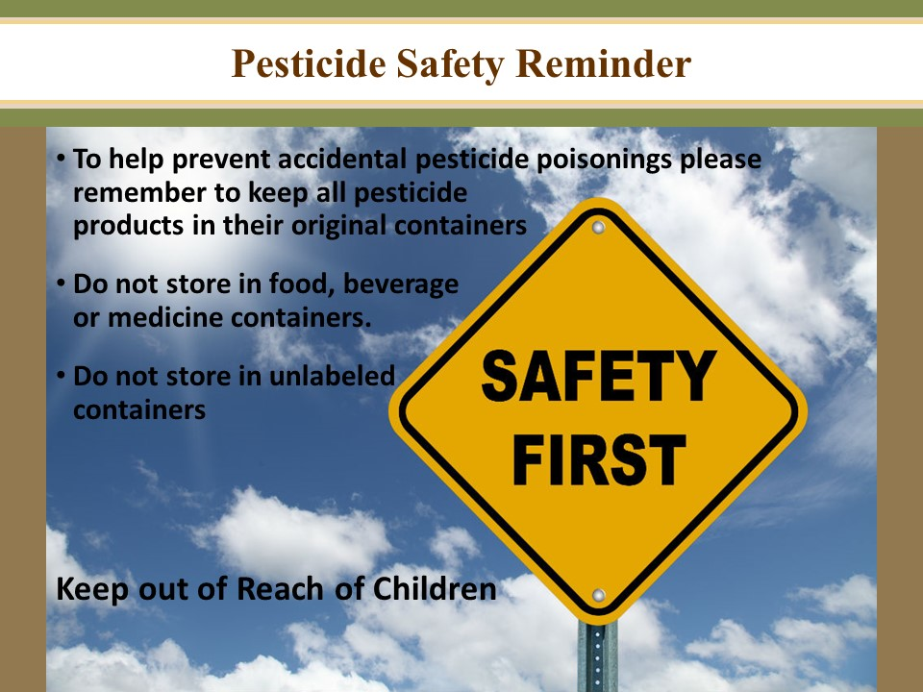

If pesticides are not stored properly, they have the potential to harm people (especially children), domestic animals, wildlife, and the environment. People or animals may swallow improperly stored pesticides or be poisoned through skin contact or inhalation.
- Store pesticides to prevent leaking and to facilitate inspection
- Do not store pesticides in unlabeled containers
- Do not store pesticides in any food, feed, beverage, or medicine container
- Do not store pesticides in a way that could contaminate food, feeds, fertilizers, seeds or other pesticides.
- Store pesticides in accordance with storage recommendations and their label
- Store pesticides to prevent access to unauthorized persons
- Store pesticides in a dry and ventilated area
- Pesticide storage areas must be free of combustibles

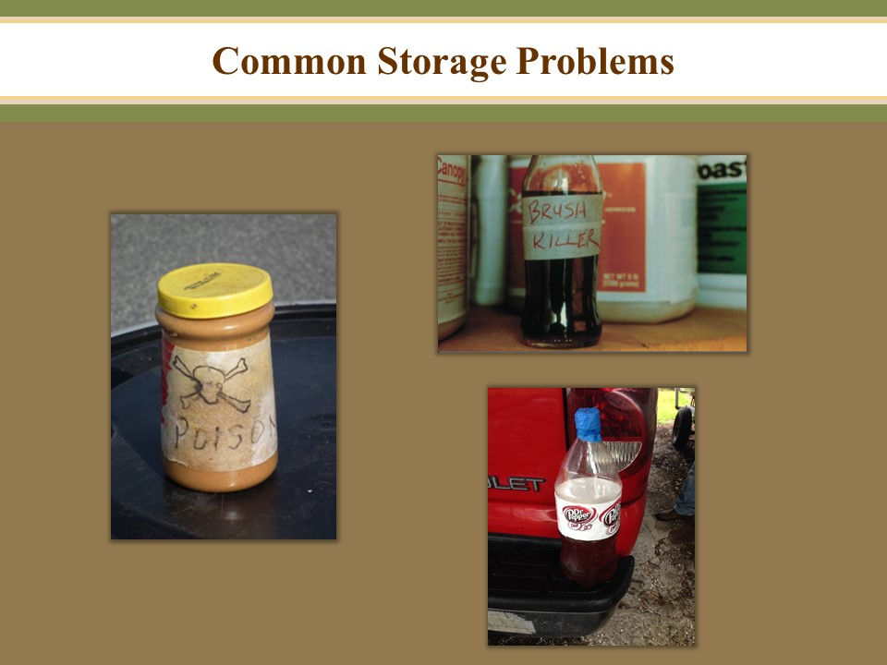

Examples of pesticides stored in food containers. Keep in mind that children may not be capable of reading and understanding labels or warning symbols.

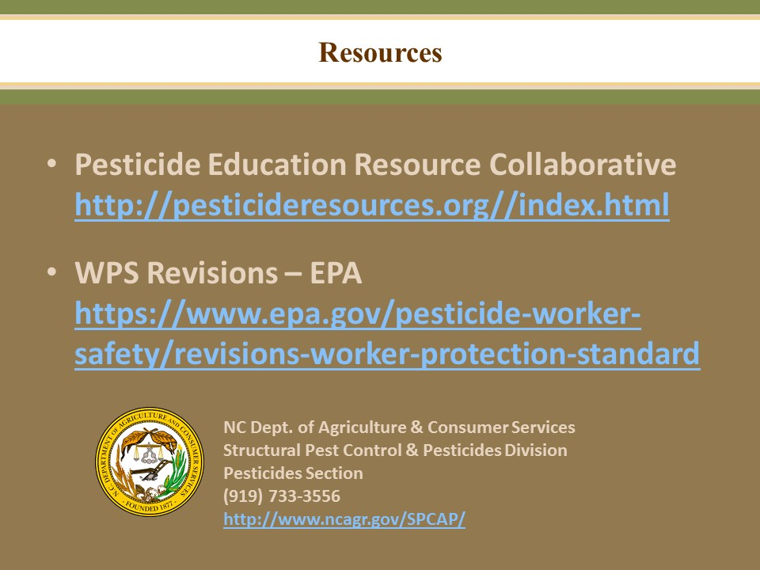

Please contact the NC Department of Agriculture with any pesticide questions or concerns.

